**Python Scraping Exercise**

**Exercise 2 – Web Scraping**

**Student Name: Gauri Mutha Student Id: 2021332634**

**Date: 01/13/2018**

**Screenshot of the CSV file**

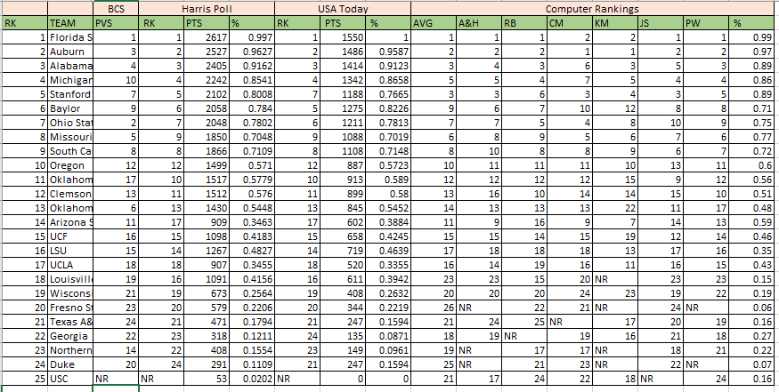

**Questions:**

1. What is A&H Ranking of Wisconsin?

**Answer**: Wisconsin’s A&H ranking is **20**.

1. What is CM Ranking of UCLA?

**Answer:** CM Ranking of UCLA is **16.**

1. List the top 5 universities based on the PVS ranking.

**Answer:** Top 5 universities based on PVS ranking are: Florida State, Ohio State, Auburn, Alabama, Missouri

1. Plot a line chart with plotted points with two data series for the following columns in your excel and paste the screen shot of your graph

* RK (First Column)
* BCS PVS (Fourth Column)

**Answer:** The line chart is as follows,